Database Design & Implementation
Sprint 3 — DDL Script & Constraints Documentation

Subject | Database Management Systems
Sprint | Sprint 3 — Physical ERD & DDL Script
Database | DBeaver
Domain | Sports Team Management System
Date | May 2026

13 Tables | 12 FK Constraints | 1 UNIQUE + 1 CHECK

. Table of Contents

1. | Physical ER Diagram | 3
2. | Database Schema Overview | 4
3. | DDL Script — Table Creation (CREATE TABLE) | 4
4. | DDL Script — Foreign Key Constraints (ALTER TABLE) | 7
5. | Constraint Documentation — UNIQUE & CHECK | 9
6. | Constraint Testing Evidence | 10
7. | DBeaver ER Diagram | 10

1. Physical ER Diagram
The Physical ER Diagram below represents the complete database schema for the Sports Team Management System. It was designed using a diagramming tool (Lucidchart/draw.io) and reflects all 13 entities, their attributes with data types, primary keys, foreign keys, and relationship cardinalities. The STAFF/COACH/MEDICAL_STAFF supertype–subtype hierarchy is clearly shown, with Role_Type serving as the subtype discriminator on the STAFF table.
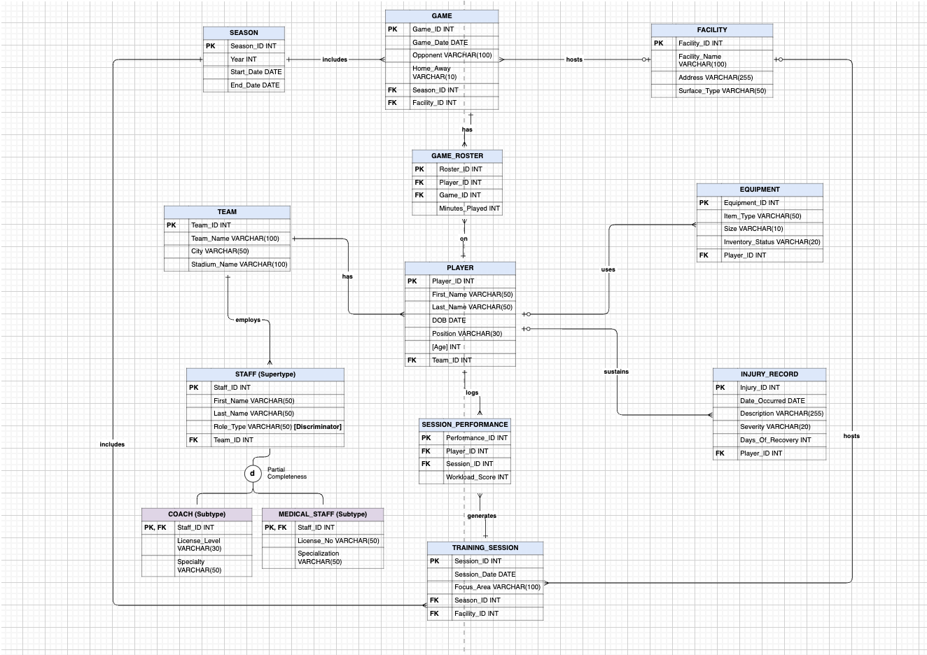

2. Database Schema Overview

The database models a Sports Team Management System with 13 tables spanning player management, game scheduling, training, equipment, injuries, and staff. The schema implements a supertype–subtype pattern for staff roles and two resolved many-to-many relationships via bridge tables.

Table | Category | Key Relationships
SEASON | Core / Reference | Referenced by GAME, TRAINING_SESSION
FACILITY | Core / Reference | Referenced by GAME, TRAINING_SESSION
TEAM | Core | Referenced by PLAYER, STAFF
PLAYER | Core | FK → TEAM; referenced by many tables
STAFF | Supertype | FK → TEAM; discriminator: Role_Type
COACH | Subtype of STAFF | FK → STAFF (Staff_ID)
MEDICAL_STAFF | Subtype of STAFF | FK → STAFF (Staff_ID); UNIQUE: License_No
GAME | Transactional | FK → SEASON, FACILITY
TRAINING_SESSION | Transactional | FK → SEASON, FACILITY
GAME_ROSTER | Bridge (M:N) | FK → PLAYER, GAME; CHECK: Minutes_Played ≥ 0
SESSION_PERFORMANCE | Bridge (M:N) | FK → PLAYER, TRAINING_SESSION
EQUIPMENT | Dependent | FK → PLAYER
INJURY_RECORD | Dependent | FK → PLAYER

3. DDL Script — Table Creation (CREATE TABLE)
All tables are created below. Primary Keys are defined at the column level. Foreign Key constraints are applied separately via ALTER TABLE in Section 4, following the recommended practice. The Role_Type column on STAFF acts as the subtype discriminator for the COACH / MEDICAL_STAFF hierarchy.
-- =============================================================
-- SECTION 3: TABLE CREATION (PRIMARY KEYS AT COLUMN LEVEL)
-- =============================================================

-- Reference / Lookup tables first (no outbound FKs) CREATE TABLE SEASON (
Season_ID INT PRIMARY KEY,
Year INT, Start_Date DATE, End_Date DATE
);

CREATE TABLE FACILITY (
Facility_ID INT PRIMARY KEY, Facility_Name VARCHAR(100), Address VARCHAR(255), Surface_Type VARCHAR(50)
);

CREATE TABLE TEAM ( Team_ID INT PRIMARY KEY,
Team_Name VARCHAR(100), City VARCHAR(50),
Stadium_Name VARCHAR(100)
);

-- Core entities CREATE TABLE PLAYER (
Player_ID INT PRIMARY KEY,
First_Name VARCHAR(50), Last_Name VARCHAR(50), DOB DATE,
Position VARCHAR(30),
Age INT,

Team_ID INT -- FK → TEAM (added in Section 4)
);
-- SUPERTYPE: STAFF (Role_Type = subtype discriminator)
CREATE TABLE STAFF (
Staff_ID INT PRIMARY KEY,
First_Name VARCHAR(50),
Last_Name VARCHAR(50),
Role_Type VARCHAR(50), -- Discriminator: 'Coach' | 'Medical'
Team_ID INT -- FK → TEAM (added in Section 4)
);
-- SUBTYPES of STAFF
CREATE TABLE COACH (
Staff_ID INT PRIMARY KEY, -- PK and FK → STAFF
License_Level VARCHAR(30),
Specialty VARCHAR(50)
);
CREATE TABLE MEDICAL_STAFF (
Staff_ID INT PRIMARY KEY, -- PK and FK → STAFF
License_No VARCHAR(50), -- UNIQUE constraint added in Section 5
Specialization VARCHAR(50)
);
-- Transactional tables
CREATE TABLE GAME (
Game_ID INT PRIMARY KEY,
Game_Date DATE,
Opponent VARCHAR(100),
Home_Away VARCHAR(10),
Season_ID INT, -- FK → SEASON
Facility_ID INT -- FK → FACILITY
);
CREATE TABLE TRAINING_SESSION (
Session_ID INT PRIMARY KEY,
Session_Date DATE,
Focus_Area VARCHAR(100),
Season_ID INT, -- FK → SEASON

Facility_ID INT -- FK → FACILITY
);

-- Bridge tables (resolved M:N relationships) CREATE TABLE GAME_ROSTER (
Roster_ID INT PRIMARY KEY, Player_ID INT, -- FK → PLAYER Game_ID INT, -- FK → GAME
Minutes_Played INT -- CHECK constraint added in Section 5
);

CREATE TABLE SESSION_PERFORMANCE (
Performance_ID INT PRIMARY KEY, Player_ID INT, -- FK → PLAYER
Session_ID INT, -- FK → TRAINING_SESSION
Workload_Score INT
);

-- Dependent tables CREATE TABLE EQUIPMENT (
Equipment_ID INT PRIMARY KEY, Item_Type VARCHAR(50),
Size VARCHAR(10),
Inventory_Status VARCHAR(20), Player_ID INT -- FK → PLAYER
);

CREATE TABLE INJURY_RECORD ( Injury_ID INT PRIMARY KEY,
Date_Occurred DATE, Description VARCHAR(255), Severity VARCHAR(20), Days_Of_Recovery INT,
Player_ID INT -- FK → PLAYER
);

4. DDL Script — Foreign Key Constraints (ALTER TABLE)

All Foreign Key constraints are added after table creation using ALTER TABLE. This approach avoids circular dependency issues and keeps creation scripts clean. A total of 12 FK constraints are defined across the schema.
-- =============================================================
-- SECTION 4: FOREIGN KEY CONSTRAINTS (ALTER TABLE)
-- =============================================================

-- PLAYER: belongs to a TEAM ALTER TABLE PLAYER
ADD CONSTRAINT fk_player_team
FOREIGN KEY (Team_ID) REFERENCES TEAM(Team_ID);

-- STAFF (supertype): belongs to a TEAM ALTER TABLE STAFF
ADD CONSTRAINT fk_staff_team
FOREIGN KEY (Team_ID) REFERENCES TEAM(Team_ID);

-- SUBTYPE CONSTRAINTS (unary / subtype relationships)
-- COACH is a STAFF member (Staff_ID shared as PK + FK) ALTER TABLE COACH
ADD CONSTRAINT fk_coach_staff
FOREIGN KEY (Staff_ID) REFERENCES STAFF(Staff_ID);

-- MEDICAL_STAFF is a STAFF member (Staff_ID shared as PK + FK) ALTER TABLE MEDICAL_STAFF
ADD CONSTRAINT fk_medical_staff
FOREIGN KEY (Staff_ID) REFERENCES STAFF(Staff_ID);

-- GAME: linked to a SEASON and a FACILITY ALTER TABLE GAME
ADD CONSTRAINT fk_game_season
FOREIGN KEY (Season_ID) REFERENCES SEASON(Season_ID);

ALTER TABLE GAME
ADD CONSTRAINT fk_game_facility
FOREIGN KEY (Facility_ID) REFERENCES FACILITY(Facility_ID);
-- TRAINING_SESSION: linked to a SEASON and a FACILITY ALTER TABLE TRAINING_SESSION

ADD CONSTRAINT fk_training_season
FOREIGN KEY (Season_ID) REFERENCES SEASON(Season_ID);

ALTER TABLE TRAINING_SESSION
ADD CONSTRAINT fk_training_facility
FOREIGN KEY (Facility_ID) REFERENCES FACILITY(Facility_ID);

-- GAME_ROSTER (bridge): links PLAYERs to GAMEs ALTER TABLE GAME_ROSTER
ADD CONSTRAINT fk_roster_player
FOREIGN KEY (Player_ID) REFERENCES PLAYER(Player_ID);

ALTER TABLE GAME_ROSTER
ADD CONSTRAINT fk_roster_game
FOREIGN KEY (Game_ID) REFERENCES GAME(Game_ID);

-- SESSION_PERFORMANCE (bridge): links PLAYERs to TRAINING_SESSIONs ALTER TABLE SESSION_PERFORMANCE
ADD CONSTRAINT fk_perf_player
FOREIGN KEY (Player_ID) REFERENCES PLAYER(Player_ID);

ALTER TABLE SESSION_PERFORMANCE
ADD CONSTRAINT fk_perf_session
FOREIGN KEY (Session_ID) REFERENCES TRAINING_SESSION(Session_ID);

-- EQUIPMENT: assigned to a PLAYER ALTER TABLE EQUIPMENT
ADD CONSTRAINT fk_equipment_player
FOREIGN KEY (Player_ID) REFERENCES PLAYER(Player_ID);

-- INJURY_RECORD: recorded for a PLAYER ALTER TABLE INJURY_RECORD
ADD CONSTRAINT fk_injury_player
FOREIGN KEY (Player_ID) REFERENCES PLAYER(Player_ID);

FK Constraint Summary

Constraint Name | Table | Column | References
fk_player_team | PLAYER | Team_ID | TEAM(Team_ID)
fk_staff_team | STAFF | Team_ID | TEAM(Team_ID)
fk_coach_staff | COACH | Staff_ID | STAFF(Staff_ID)
fk_medical_staff | MEDICAL_STAFF | Staff_ID | STAFF(Staff_ID)

fk_game_season | GAME | Season_ID | SEASON(Season_ID)
fk_game_facility | GAME | Facility_ID | FACILITY(Facility_ID)
fk_training_season | TRAINING_SESSION | Season_ID | SEASON(Season_ID)
fk_training_facility | TRAINING_SESSION | Facility_ID | FACILITY(Facility_ID)
fk_roster_player | GAME_ROSTER | Player_ID | PLAYER(Player_ID)
fk_roster_game | GAME_ROSTER | Game_ID | GAME(Game_ID)
fk_perf_player | SESSION_PERFORMANCE | Player_ID | PLAYER(Player_ID)
fk_perf_session | SESSION_PERFORMANCE | Session_ID | TRAINING_SESSION(Session_ID)
fk_equipment_player | EQUIPMENT | Player_ID | PLAYER(Player_ID)
fk_injury_player | INJURY_RECORD | Player_ID | PLAYER(Player_ID)

5. Constraint Documentation — UNIQUE & CHECK

Per the sprint requirements, one UNIQUE constraint and one CHECK constraint have been added using
ALTER TABLE. Both are logically motivated by real-world business rules, not added arbitrarily.
Table:
MEDICAL_STAFF
Column:
License_No
Purpose:
A medical license number is a government-issued credential that uniquely identifies a licensed healthcare professional. No two medical staff members can legally hold the same license number. This constraint enforces data integrity at the database level and prevents duplicate
registrations from occurring.
-- UNIQUE CONSTRAINT
-- Table: MEDICAL_STAFF | Column: License_No
-- Rationale: Every medical license number is legally unique to one individual.
-- Prevents duplicate registrations in the system.

ALTER TABLE MEDICAL_STAFF
ADD CONSTRAINT uq_medical_license UNIQUE (License_No);
UNIQUE CONSTRAINT
CHECK CONSTRAINT
Table:
GAME_ROSTER
Column:
Minutes_Played
Purpose:
Minutes played in a game is a non-negative measurement — it is physically impossible for a player to have played a negative number of minutes. This constraint guards against data entry
errors and ensures analytical integrity when computing playing-time statistics.
-- CHECK CONSTRAINT
-- Table: GAME_ROSTER | Column: Minutes_Played
-- Rationale: Playing time cannot be a negative number.
-- Protects against invalid data entry errors.

ALTER TABLE GAME_ROSTER
ADD CONSTRAINT chk_minutes_played CHECK (Minutes_Played >= 0);

Constraint Location Summary

UNIQUE → MEDICAL_STAFF.License_No (uq_medical_license)
CHECK → GAME_ROSTER.Minutes_Played >= 0 (chk_minutes_played)

6. Constraint Testing Evidence

Both constraints were tested in MariaDB to confirm correct enforcement. The test cases below demonstrate expected error behavior.

Test 1 — UNIQUE Constraint on MEDICAL_STAFF.License_No
-- Setup: insert a medical staff record
INSERT INTO STAFF VALUES (1, 'Ana', 'Rivera', 'Medical', 101); INSERT INTO MEDICAL_STAFF VALUES (1, 'ML-00492', 'Orthopedics');
-- Attempt to insert a SECOND record with the same License_No INSERT INTO STAFF VALUES (2, 'Ben', 'Torres', 'Medical', 101); INSERT INTO MEDICAL_STAFF VALUES (2, 'ML-00492', 'Cardiology');
-- ✗ ERROR 1062 (23000): Duplicate entry 'ML-00492' for key 'uq_medical_license'
-- ✓ Constraint is working correctly.

Test 2 — CHECK Constraint on GAME_ROSTER.Minutes_Played
-- Setup: insert required parent records first
INSERT INTO SEASON VALUES (1, 2024, '2024-09-01', '2025-06-01');
INSERT INTO FACILITY VALUES (1, 'Home Arena', '123 Main St', 'Hardwood');
INSERT INTO TEAM VALUES (101, 'City Hawks', 'Tampa', 'Hawks Arena');
INSERT INTO PLAYER VALUES (10, 'Jake', 'Smith', '1998-04-12', 'Guard', 26, 101);
INSERT INTO GAME VALUES (50, '2024-11-10', 'River Lions', 'Home', 1, 1);

-- Attempt to insert a negative minutes value INSERT INTO GAME_ROSTER VALUES (1, 10, 50, -5);
-- ✗ ERROR 4025 (23000): CONSTRAINT chk_minutes_played failed for
-- `sports_db`.`GAME_ROSTER`
-- ✓ Constraint is working correctly.

-- Valid insert succeeds
INSERT INTO GAME_ROSTER VALUES (1, 10, 50, 32);
-- ✓ 1 row(s) affected.

7. DBeaver ER Diagram

After executing all DDL scripts in MariaDB, the ER Diagram was exported from DBeaver. The diagram reflects the physical database structure with all 13 tables, their columns, PKs, and FK relationships. Tables are arranged to match the physical ERD submitted in prior sprints, with no overlapping elements.
